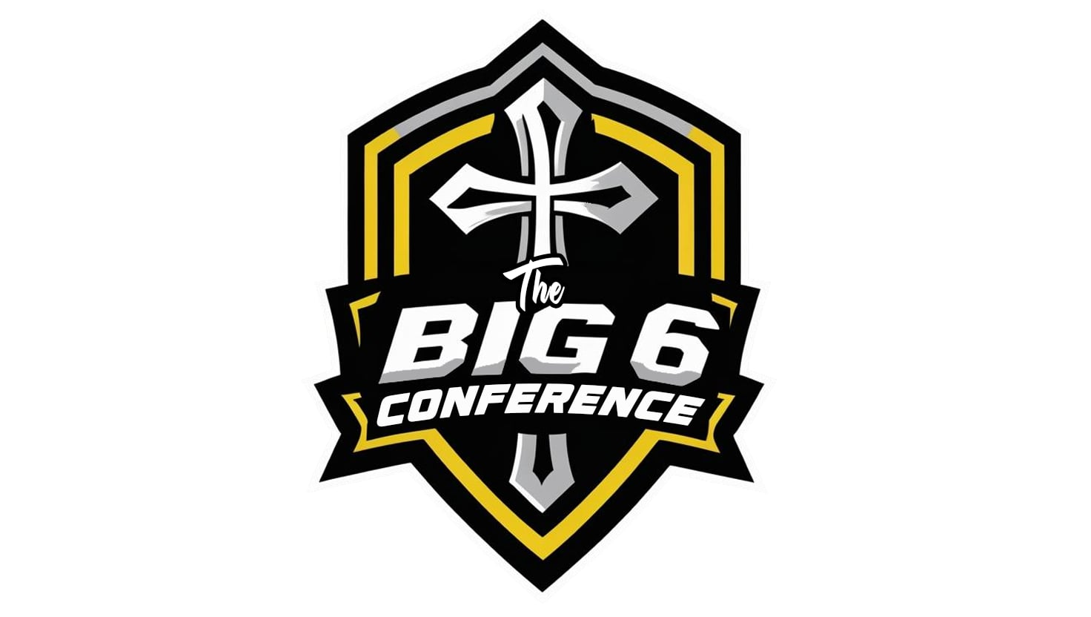**Big 6 Conference Sportsmanship Expectations**

***Introduction:*** *Admission to Big 6 Conference events is a privilege granted to students, coaches, staff, and spectators. With this privilege comes the responsibility to uphold the highest standards of sportsmanship, respect, and integrity.The goal of the Big 6 Conference is to create a safe, enjoyable, and positive environment for all participants and fans. Please review the following expectations of the Big 6 Conference.*

**Core Principles:**

**Respect**: Treat all players, coaches, officials, and spectators with courtesy and respect, regardless of the game’s outcome.

**Integrity:** Play and spectate with honesty and fairness, demonstrating good sportsmanship at all times.

**Positivity**:Promote encouragement and support for all teams and participants, fostering a spirit of unity and school pride.

**Guidelines for Coaches, Participants and Spectators:**

1. Respect Officials and Coaches: Accept decisions made by officials and listen to coaches with an open mind. Do not engage in disrespectful or disruptive behavior.

2. Positive Communication: Cheer positively and avoid negative comments or taunts directed at players, officials, or other spectators.

3. Self-Control: Maintain composure and exhibit good conduct, even in challenging situations or during disagreements.

4. Support Fair Play: Celebrate good sportsmanship and effort, regardless of the game’s result.

**Consequences for Unsportsmanlike Behavior:**

Any individual demonstrating unsportsmanlike conduct may be subject to disciplinary action, including removal from the event, suspension from future contests, or other actions deemed appropriate by Big 6 Conference Athletic Directors and School Administrators. Conference Athletic Directors and Administrators will work together at ALL events as needed to maintain Sportsmanship Expectations. Let us strive to make our athletic events a reflection of our faith and values, promoting good sportsmanship and a spirit of Christian fellowship.

Name: ________________________ Signature: ________________________

**School Role (Circle All that Apply):**

STUDENT COACH/STAFF PARENT ADMINISTRATOR/AD

***Please Note:*** *Parents/Guardians are responsible for communicating Big 6 Conference Expectations to family and friends attending events. All guests are expected to follow these expectations and are subject to disciplinary action due to sportsmanship issues.*